**CREATE AND CONFIGURE IBM CLOUD SERVICE**

**Create A Database In Cloudant DB**

|  |  |
| --- | --- |
| Date | 16 November 2022 |
| Team ID | PNT2022TMID19505 |
| Project Name | IoT Based gadget for child safety monitoring and notification |
| Maximum Marks | 4 Marks |

**Data store connector for Cloudant NoSQL DB**

* **Use IBM® Cloudant® NoSQL DB for IBM Cloud to store and access your device data in daily, weekly, or monthly databases set by on your selected bucket interval.**
* **Current bucket interval database.**
* **Upcoming interval database.**
* **When the end of an interval is reached, device data is stored in the bucket database for the new interval and a new database is created for the following interval.**
* **Configuration database.**
* **Design documents that you add to the configuration database are copied to new databases as these are created.**

**JSON:**

**If the data is valid JSON and the format of the device event is set to json, the device data is stored in the following format:**

**Bucket interval**

**{bucketName} format**

**Day yyyy-mm-dd**

**Example: 2019-07-06 for events on 6 July 2019.**

**Week yyyy-‘w’ww**

**Where ‘w’ww indicates a week number. Example: 2019-w03 for events in the third week of 2019.**

**Month yyyy-mm Example: 2019-07 for events in July 2019.**

**Database naming schema**

The destination configuration determines how IBM Maximo Asset Monitor manages the databases in your Cloudant NoSQL DB account.

The database naming schema is as follows:{destinationName}_{bucketName}, with {bucketName} determined by your choice of bucketInterval when you [configure the Cloudant NoSQL DB destination](https://www.ibm.com/docs/en/mapms/1_cloud?topic=connectors-data-store-connector-cloudant#destination):

**Configuration**

**By using the Python SDK, you can set up a Cloudant NoSQL DB binding in just a few lines of code. For more information about how to get your IoT data forwarded to Cloudant NoSQL DB, see the Python SDK documentation for DSC.**

**You can also use the following code sample to configure two destinations and forwarding rules to ensure that all events and all states are forwarded.**

**Step 1: Set up the service binding**

**To configure a service binding to Cloudant NoSQL DB, you need the following Cloudant NoSQL DB information:**

**Username**

**Password**

**Host**

**Port**

**With this information, you can call the API to create a new Cloudant NoSQL DB service binding.**

**When the service binding completes, a serviceId is returned. You need this 36 character UUID when you set up the connector instance.**

**Other data**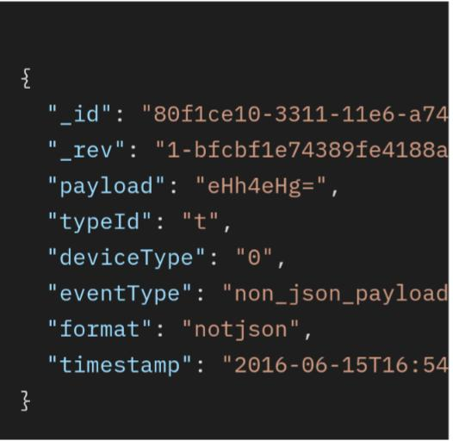

**Device data is stored in a database either as JSON or as base64 depending on the data type.**

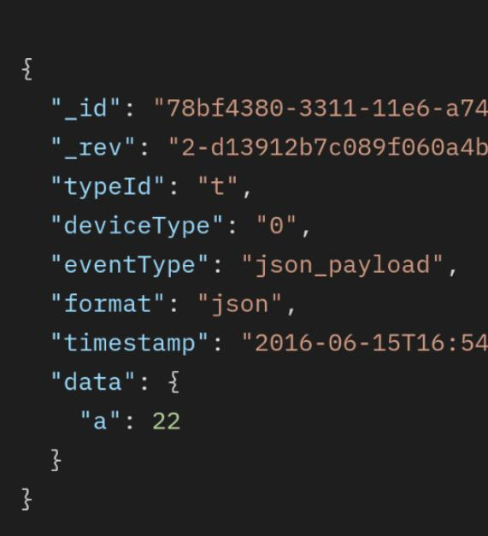

Device data that is not valid JSON or where the format is not set to json is stored as a base64 encoded strings under the payload field in the following format:

You can also use the following code sample to configure two destinations and forwarding rules to ensure that all events and all states are forwarded.